Quotation:

Geosim to Trackmap Interface (GTI) for Helicopter Resources.

## **Aim:** Simulate aerial seeding and survey flying.

Using the existing Geosim, Pilots can receive instruction on how to use the Trackmap unit in a controlled environment. The pilots can practice the necessary flying methods while using the Trackmap to produce GPS guided tracks over the ground. Those skills can then be applied into the field for aerial seeding or survey flying.

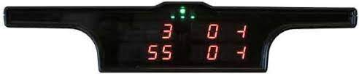

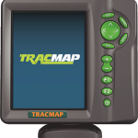For details about Trackmap: <https://tracmap.com/aviation/>

## **Method:** Interface the Geosim to the Trackmap.

The Geosim flight simulator is based on X-plane 10 which has a feature where the location of the simulated aircraft can be sent out the PC serial port as a standard GPS NMEA sentence.

Below is an example of the NMEA sentences.

|  |
| --- |
| $GPGGA,092750.000,5321.6802,N,00630.3372,W,1,8,1.03,61.7,M,55.2,M,,*76  $GPGSA,A,3,10,07,05,02,29,04,08,13,,,,,1.72,1.03,1.38*0A  $GPGSV,3,1,11,10,63,137,17,07,61,098,15,05,59,290,20,08,54,157,30*70  $GPGSV,3,2,11,02,39,223,19,13,28,070,17,26,23,252,,04,14,186,14*79  $GPGSV,3,3,11,29,09,301,24,16,09,020,,36,,,*76  $GPRMC,092750.000,A,5321.6802,N,00630.3372,W,0.02,31.66,280511,,,A*43  $GPGGA,092751.000,5321.6802,N,00630.3371,W,1,8,1.03,61.7,M,55.3,M,,*75  $GPGSA,A,3,10,07,05,02,29,04,08,13,,,,,1.72,1.03,1.38*0A  $GPGSV,3,1,11,10,63,137,17,07,61,098,15,05,59,290,20,08,54,157,30*70  $GPGSV,3,2,11,02,39,223,16,13,28,070,17,26,23,252,,04,14,186,15*77  $GPGSV,3,3,11,29,09,301,24,16,09,020,,36,,,*76  $GPRMC,092751.000,A,5321.6802,N,00630.3371,W,0.06,31.66,280511,,,A*45 |

More Info at <https://en.wikipedia.org/wiki/NMEA_0183>

The GPS NMEA sentence is what the Trackmap would normally receive from its own GPS receiver module. If the TrackMap is supplied with the X-plane’s sentence, Trackmap will interpret the data as if it was onboard an aircraft

The Trackmap will be mounted on a custom frame that sits beside the Geosim pilot’s seat. It would be positioned in a similar location to the aircraft. The unit will be powered by a standard 12v battery or a suitable power supply.

The Lightbar will be placed in the pilots eyeline using its own mount.

The Trackmap switches will be attached to the Geosim cyclic in the same way as the aircraft.

## 

## Digital Interface:

Unfortunately, it is not a simple task of connecting the Geosim PC to the Trackmap and everything works...

The Tackmap is expecting to communicate over an industry-standard RS232 serial input and the data must be transferred at 9600 bits per second or higher.

The Geosim PC does not have a standard RS232 serial port as modern PC systems have done away with this method of communication. Additionally, X-plane sends the data out at the NMEA standard rate of 4800 bits per second.

To solve the above issues, The interface will be built around an Arduino microprocessor.

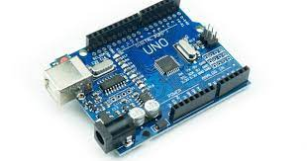

These units are obtained from Jaycar or other online sources. The microprocessor (MPU) can be programmed using pre-existing and extensively tested software libraries. One of those libraries is serial communications.

The incoming x-plane NMEA sentence at 4800 bps will be stored inside the MPU. The MPU will check that the sentence is valid then send the NMEA sentence onto the Trackmap at 9600 bps.

Another library will emulate an RS232 serial port over a USB connection. Windows 10 will use its standard drivers to support this and X-plane will think it is communicating to a physical RS232 serial port.

Finally, the MPU will be connected to an RS232 adapter board that creates the required voltage levels to comply with the RS232 standard.

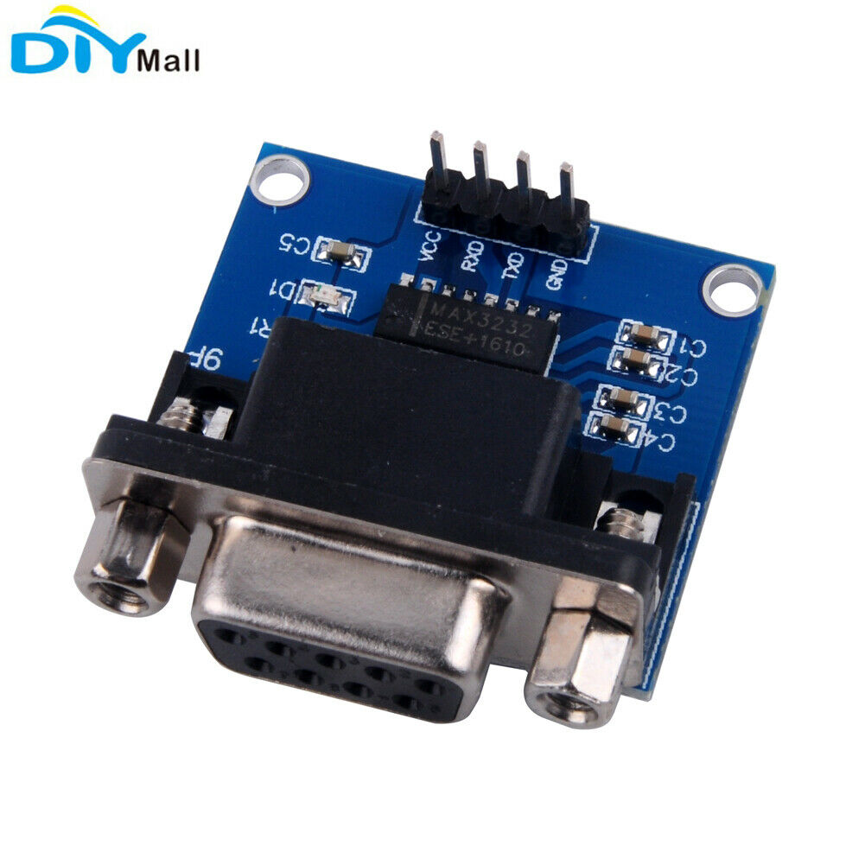

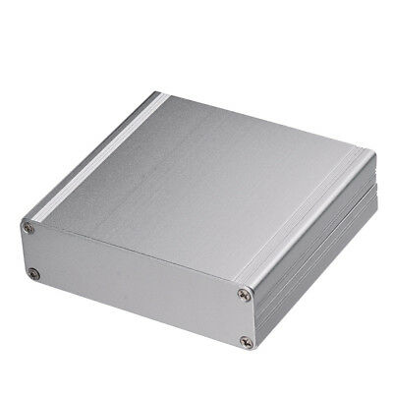

All the boards will be mounted into a suitable box and the required physical connections placed on the sides. Labeled LED lights will be installed for status and fault finding.

All documents, diagrams, and code will be held on GitHub for future reference.

## 

## TrackMap Mounting Hardware:

The Trackmap display and Light bar must be mounted in a similar location to where it is normally installed in the aircraft. The mounts must be easily attached or removed from the simulator to allow the simulator to be configured between tasks without engineering support and must be sturdy enough to not pose a hazard to the pilots, Simulator or the Trackmap equipment.

The Helicopter Resources engineers have the resources and skills to construct the mounting hardware. Helicopter Resources could allocate the personnel to the task during periods when the engineers are free from other commitments. The materials would most likely be sourced from the offcuts and scraps around the hangar.

Andrew Harrison's role would be to work with them to design and create the mounts.

## Cost and ETD:

GTI Hardware - ~$150

* 1x Arduino Microprocessor
* 1x RS232 Adapter Board
* 1x 200mm Poly box or aluminum box
* 4x Industrial LED lights

Isolated and protected 12V power supply - $100

Arduino Software and Hardware Development - $5720

* Develop the Arduino code - 30 hours
* Assemble units into a box - 10 hours
* Test and debug the system - 10 hours
* Document and backup code. - 2 hours

Trackmap mounting hardware - (inhouse construction - see above)

* 1x Trackmap stand
* 1x Lightbar stand

Estimated Total cost - $5970

Estimated Time to delivery - Three weeks.

## Payment:

To initiate the project, Andrew Harrison would require the necessary funds to purchase the electronic hardware. $250 will be deposited into his account.

The remainder will be paid on completion of the Arduino Software and Hardware Development stage.

Payment Details:

Andrew Harrison

Wetspac

BSB: 733-186

Account: 721575

ABN: 73340887092